Initial Set up

This suit is designed to run on Windows using Chrome.

Although if you desire to run in on other OS, please modify the driver accordingly for each test suit.

For MacOs, please change this line for:

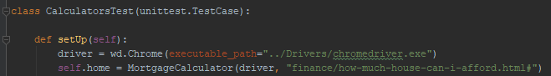

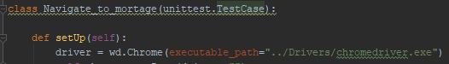

driver = wd.Chrome(executable_path="../Drivers/chromedriver_Mac")

For Linux, please change this line for:





driver = wd.Chrome(executable_path="../Drivers/chromedriver_Linux")

Running the Program.

To run the Part one section please use the Test_Calculator.py file:

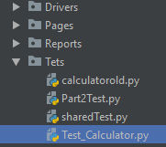

The main class is MyTestSuite



To run the Part one section please use the Part2Test.py file:

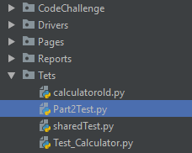

The main class is MyTestSuite

